Agenda Item : 2/09

= application site



21 Whitegate Gardens | P/3800/18

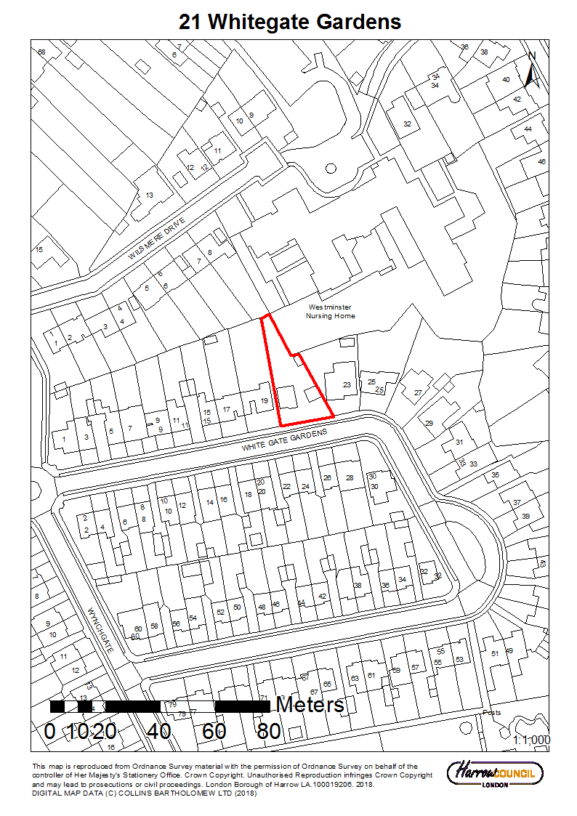
LONDON BOROUGH OF HARROW

PLANNING COMMITTEE

30th May 2018

Application Number: | P/3800/18
Validate Date: | 12/09/2018
Location: | 21 WHITEGATE GARDENS
Ward: | HARROW WEALD
Postcode: | HA3 6BW
Applicant: | MR PHILIP ECCLES
Agent: | N/A
Case Officer: | LOKENDRA CHEMJONG
Expiry Date: | 06/11/2018 (EXTENDED TO 28/11/2018)

PROPOSAL

Re-development to provide a pair of semi-detached dwellinghouses with habitable roofspace; new vehicle access onto Whitegate Gardens; parking; amenity space; boundary treatment; landscaping and bin storage.

The Planning Committee is asked to:

RECOMMENDATION

- agree the reasons for approval as set out in this report, and

- grant planning permission subject to the Conditions listed in Appendix 1 of this report.

REASON FOR THE RECOMMENDATIONS

The proposal would contribute towards the housing stock within the borough and the quality of accommodation for the future occupiers of the dwellinghouses would be in accordance with the development plan and policies. Furthermore, it is considered that the proposal would not have an unduly harmful impact on the character of the area or the residential amenities of the neighbouring occupiers.

INFORMATION

This application is reported to Planning Committee as a nominated member has requested in writing that application be reported to Planning Committee.

Statutory Return Type: | (E)13. Minor Dwellings
Council Interest: | N/A
GLA Community Infrastructure Levy (CIL) Contribution (provisional): | £5995.5
Local CIL requirement: | £18,843

HUMAN RIGHTS ACT

The provisions of the Human Rights Act 1998 have been taken into account in the processing of the application and the preparation of this report.

EQUALITIES

In determining this planning application the Council has regard to its equalities obligations including its obligations under section 149 of the Equality Act 2010.

For the purposes of this application there are no adverse equalities issues.

S17 Crime & Disorder Act

Policies 7.3.B and 7.13.B of The London Plan and Policy DM1 of the Development Management Polices Local Plan require all new developments to have regard to safety and the measures to reduce crime in the design of development proposal. It is considered that the development does not adversely affect crime risk.

LOCAL GOVERNMENT (ACCESS TO INFORMATION) ACT 1985
BACKGROUND PAPERS USED IN PREPARING THIS REPORT:

- Planning Application
- Statutory Register of Planning Decisions
- Correspondence with Adjoining Occupiers
- Correspondence with Statutory Bodies
- Correspondence with other Council Departments
- Nation Planning Policy Framework
- London Plan
- Local Plan - Core Strategy, Development Management Policies, SPGs
- Other relevant guidance

LIST OF ENCLOSURES / APPENDICES:

Officer Report:
Part 1: Planning Application Fact Sheet
Part 2: Officer Assessment
Appendix 1 – Conditions and Informatives
Appendix 2 – Site Plan
Appendix 3 – Site Photographs
Appendix 4 – Plans and Elevations

OFFICER REPORT

PART 1: Planning Application Fact Sheet

The Site

Address | 21 Whitegate Gardens, Harrow, HA3 6BW
Applicant | Mr Philip Eccles
Ward | Harrow Weald
Local Plan allocation | N/A
Conservation Area | N/A
Listed Building | N/A
Setting of Listed Building | N/A
Building of Local Interest | N/A
Tree Preservation Order | N/A
Other | N/A

Housing

Density | Proposed Density hr/ha | 270.8
Density | Proposed Density u/ph | 38.8
Density | PTAL | 0
Density | London Plan Density Range | Suburban
Dwelling Mix | Studio (no. / %) | 0
Dwelling Mix | 1 bed ( no. / %) | 0
Dwelling Mix | 2 bed ( no. / %) | 0
Dwelling Mix | 3 bed ( no. / %) | 0
Dwelling Mix | 4 bed ( no. / %) | 2
Dwelling Mix | Overall % of Affordable Housing | 0
Dwelling Mix | Social Rent (no. / %) | 0
Dwelling Mix | Intermediate (no. / %) | 0
Dwelling Mix | Private (no. / %) | 2
Dwelling Mix | Commuted Sum | N/A
Dwelling Mix | Comply with London Housing SPG? | Yes
Dwelling Mix | Comply with London Housing SPG? | Yes
Dwelling Mix | Comply with M4(2) of Building Regulations? | Conditioned

Transportation

Car parking | No. Existing Car Parking spaces | 3
Car parking | No. Proposed Car Parking spaces | 3
Car parking | Proposed Parking Ratio | 1.5:1
Cycle Parking | No. Existing Cycle Parking spaces | 0
Cycle Parking | No. Proposed Cycle Parking spaces | 1 per dwellinghouse (Conditioned to meet London Plan 2016 requirement)
Cycle Parking | Cycle Parking Ratio | 1:1
Public Transport | PTAL Rating | 0
Public Transport | Closest Rail Station / Distance (m) | Headstone Lane/ 1800m
Public Transport | Bus Routes | Kenton Lane (nearest)
Parking Controls | Controlled Parking Zone? | No
Parking Controls | CPZ Hours | N/A
Parking Controls | Previous CPZ Consultation (if not in a CPZ) | N/A
Parking Controls | Other on-street controls | N/A
Parking Stress | Area/streets of parking stress survey | -
Parking Stress | Dates/times of parking stress survey | -
Parking Stress | Summary of results of survey | -
Refuse/Recycling Collection | Summary of proposed refuse/recycling strategy | Collected by the LPA

Sustainability / Energy

BREEAM Rating | -
Development complies with Part L 2013? | -
Renewable Energy Source / % | -
PART 2: Assessment

- SITE DESCRIPTION

1.1 Subject property is a two storey detached dwellinghouse located on the northern side of Whitegate Gardens.

1.2 Subject dwelling has no. 23 Whitegate Gardens to east and has no. 19 Whitegate Gardens to west.

1.3 Rear boundary is connected to no. 8 Wilsmere Drive and Wilsmere House.

1.4 Subject dwelling is not a listed building or located in a conservation area or within any other land designated under Article 2(3) of the GPDO 2015.

1.5 The site lies within a critical drainage area.

- PROPOSAL

2.1 Re-development to provide a set of semi-detached dwellinghouses with habitable roofspace.

2.2 The existing dwellinghouse would be demolished and replaced with a pair of semi-detached houses.

2.3 The pair of semi-detached houses would have gabled roof and a rear roof dormer, and rooflights on the front roofslope. The dwellinghouses would be two storeys with habitable roofspace.

2.4 Proposed semi-detached dwellinghouse to the west (western dwellinghouse), adjacent no. 19 Whitegate Gardens, would have three storey, contain four bedrooms, a combined living and kitchen room, an office/ storage room, two bathrooms and a water closet. It would accommodate up to seven people. It would have Gross Internal Area (GIA) of 136.4 sqm.

2.5 Proposed semi-detached dwellinghouse to the east (eastern dwellinghouse), adjacent no. 23 Whitegate Gardens, would have three storey, contain four bedrooms, a combined living and kitchen room, a study room, a large storage room, two bathrooms and a water closet. It would accommodate up to seven people. It would have Gross Internal Area (GIA) of 136.4 sqm.

2.6 Formation of separate outdoor rear amenity areas.

2.7 Refuse bins and cycle storage.

2.8 Hardsurfacing, vehicular access and soft landscaping at forecourts.

2.9 Parking and boundary treatment

- RELEVANT PLANNING HISTORY

3.1 A summary of the relevant planning application history is set out in the table below:

Ref no. | Description | Status and date of decision
LBH/34342 | Two storey side to rear extension to provide new dwelling unit and garages | Refused on 04/02/1988
P/0966/18 | Re-development to provide a pair of semi-detached dwellings with habitable roofspace; new vehicle access onto Whitegate Gardens; parking; amenity space; boundary treatment; landscaping and bin storage | Refused on 10/05/2018; Currently undergoing appeal process  Reason for refusal:  Principle of Garden Land Development
P/2856/18 | Certificate of lawful proposed development: front porch; single storey side extension; single storey rear extension | Granted on 22/08/2018
P/3123/18/PRIOR | Single storey rear extension: extending 8 metres beyond the original rear wall 2.7 Metres maximum height 2.7 Metres high to the eaves | Prior approval not required on 24/08/2018.

- CONSULTATION

4.1 A total of five consultation letters were sent to neighbouring properties regarding this application.

4.2 The overall public consultation period expired on 03/10/2018

4.3 Adjoining Properties

Number of letters Sent | 5
Number of Responses Received | 1
Number in Support | 0
Number of Objections | 1
Number of other Representations (neither objecting or supporting) | 0

4.5 A summary of the responses received along with the Officer comments are set out below:

Summary of Comments | Officer Comments
Objections to the application due to:  - Concerns regarding substantial development in restricted space, overall size and scale of proposed dwelling  - gable end design and rear dormer would create overbearing visual impact  - Would block daylight and be out of character  - Put additional pressure on parking  - Garden Land Development | Issues relating to principle of development (garden land), character, residential amenity, and parking are assessed in sections 6.2, 6.3, 6.4 and 6.5 of the report respectively.

4.6 Statutory and Non Statutory Consultation

4.7 The following consultations have been undertaken:

LBH Highways Authority
LBH Landscape Architect
Designing Out Crime Officer, Metropolitan Police Service
LBH Drainage Authority
Vehicle Crossings Authority
Arboricultural Asset Officer
LBH Waste Management Policy Officer
Thames Water Utilities Ltd

4.8 Statutory and Non Statutory Consultation

4.9 A summary of the consultation responses received along with the Officer comments are set out in the Table below.

Summary of Comments | Officer Comments
LBH Highways:  This development proposal is broadly acceptable. Further information is required in relation to the likelihood of the proposed vehicle crossings being accepted. The main concern relates to the proximity of the crossing to street tree. This information should be obtained. The proposed cycle parking is of poor quality and under the minimum requirements for dwellings of this size. Each house should provide sheltered, secure and accessible cycle storage for a minimum of two cycles. Details of the type of storage and the locations can be secured via pre-occupation condition should the application be granted. | Condition attached regarding construction method statement and cycle parking.
LBH Landscape Architect:  The proposal should be conditioned for details of hard and soft landscape works, planting, levels and boundary treatment; the proposed vehicle crossing should be located 2m away from the street tree. | Condition attached requesting details for hard and soft landscape, and bins.
Designing Out Crime Officer, Metropolitan Police Service:  The proposal is not within the remit of Secured by Design Officer as the no. of proposed units is less than 5. The proposal could however achieve Secured By Design accreditation and the developer should contact Secured by Design officer at the earliest opportunity. | Condition attached requiring to achieve Secure by Design accreditation.
LBH Drainage:  Details of proposed drainage, permeable hard surfacing and maintenance plans needs to be submitted to be approved by the drainage team, to comply with Policy DM 10. | Condition attached requesting drainage details.
Arboricultural Asset Officer:  The proposed vehicle crossing for the western dwelling needs to be located 2m away from the street tree. | The vehicle crossing would be located 2m away from the street tree.
Vehicle Crossings Officer:  The proposed vehicle crossing would be acceptable. | N/A
LBH Waste Management Policy Officer:  No comments received. | N/A
Thames Water Utilities Ltd:  No comments received. | N/A

- POLICIES

5.1 Section 38(6) of the Planning and Compulsory Purchase Act 2004 requires that:

‘If regard is to be had to the Development Plan for the purpose of any determination to be made under the Planning Acts, the determination must be made in accordance with the Plan unless material considerations indicate otherwise.’

5.2 The Government has issued the National Planning Policy Framework [NPPF] which is a material consideration in the determination of this application.

5.3 In this instance, the Development Plan comprises The London Plan 2015 [LP], The Draft London Plan 2017 [DLP] and the Local Development Framework [LDF]. The LDF comprises The Harrow Core Strategy 2012 [CS], Harrow and Wealdstone Area Action Plan 2013 [AAP], the Development Management Policies Local Plan 2013 [DMP], the Site Allocations Local Plan [SALP] 2013 and Harrow Local Area Map 2013 [LAP].

5.4 A full list of all the policies used in the consideration of this application is provided as Informative 1 in Appendix 1 of this report.

6.0 ASSESSMENT

6.1 The main issues are;

- Principle of the Development
- Character and Appearance of the Area
- Residential Amenity and Accessibility
- Traffic and Parking
- Drainage

6.2 Principle of Development

6.2.1 Paragraph 11 of the NPPF (2018) recommends approving development proposals that accord with an up-to-date development plan without delay.

6.2.2 Paragraph 70 of the NPPF (2018) states that ‘…plans should consider the case for setting out policies to resist inappropriate development of residential gardens, for example where development would cause harm to the local area.’

6.2.3 Policy 3.5 of the London Plan (2016) states that Boroughs may introduce a presumption against development on private residential gardens where this can be locally justified. Following on from National and Regional Planning Guidance, Harrow's Core Strategy includes such a presumption, having been locally justified and independently examined through the development plan process.

6.2.4 To this end, policy CS1 (A) of Harrow's adopted Core Strategy directs residential and other development to the Harrow & Wealdstone Intensification Area, town centres and, in suburban areas, to strategic previously developed sites whilst policy CS1 (B) resists development on garden sites, recognising the propensity for such proposals to lead to unmanaged, incremental growth that undermines the spatial strategy.

6.2.5 The Council has adopted a Garden Land Development Supplementary Planning Document (GLDSPD). This document has been subject to public consultation and was adopted on 11 April 2013 following on from National and Regional Planning Guidance, Harrow's Core Strategy includes such a presumption, having been locally justified and independently examined through the development plan process.

6.2.6 Paragraph 3.6 pf the GLDSPD (2013) clarifies that the redevelopment of an existing dwelling or group of dwellings to provide multiple dwellings or flats on the same building footprint, plus any appropriate enlargement(s) would not be garden land development.

The GLDSPD (2013) identifies appropriate enlargements as:

- the footprint of any permitted extensions (excluding outbuildings) that could be exercised for the dwelling(s); or
- the footprint of an extension (excluding outbuildings) that would be consistent with Harrow's Residential Design Guide SPD.

6.2.7 The Council’s SPD Residential Design Guide (2010) considers 4m rear extension to be appropriate for a semi-detached dwellinghouse. Furthermore, the detached dwellinghouse can also have side extension and front extension. Having regard to the SPD Residential Design Guide (2010), a single storey side to rear extension with projecting 4m beyond the rear wall of the original house and half the width (3.15m) of the original house beyond the side wall is considered to be appropriate enlargement. A front porch of 3sqm in line with permitted development is also considered to be appropriate. Overall, the appropriate enlargement for the subject property having regard to the SPD Residential Design Garden (2010) would be 67.6 sqm (64.6 for a single storey side to rear extension and 3 sqm for porch). The total footprint allowed for redevelopment including the footprint of the existing house would be 119.6 sqm.

6.2.8 The cumulative footprint proposed for the redevelopment would be 107.2 sqm at the ground floor level and 118 sqm at first floor level. The higher 118 sqm footprint at the first floor level would be within the allowance of 119 sqm (cumulative footprint considered to include footprint of the original house and footprint of extensions that would be consistent with Harrow’s SPD Residential Deign Guide 2010).

6.2.9 As per the paragraph 3.6 of the GLDSPD (2013), the proposal would not be considered garden land development and would therefore be acceptable in principle.

6.3 Character and Appearance of the Area

6.3.1 National Planning Policy Framework (2018) advises at paragraph 127 that planning policies and decisions should aim to ensure that developments should optimise the potential of the site to accommodate development and respond to local character and history and reflect the identity of local surroundings and materials.

6.3.2 The London Plan (2016) policies 7.4B and 7.6B set out the design principles that all boroughs should seek to ensure for all development proposals. The London Plan (2016) policy 7.4B states, inter alia, that all development proposals should have regard to the local context, contribute to a positive relationship between the urban landscape and natural features, be human in scale, make a positive contribution and should be informed by the historic environment. The London Plan (2016) policy 7.6B states, inter alia, that all development proposals should; be of the highest architectural quality, which complement the local architectural character and be of an appropriate proportion composition, scale and orientation.

6.3.3 Core Policy CS(B) states that ‘All development shall respond positively to the local and historic context in terms of design, siting, density and spacing, reinforce the positive attributes of local distinctiveness whilst promoting innovative design and/or enhancing areas of poor design; extensions should respect their host building.’

6.3.4 Policy DM 1 A of the Local Development Management Policies Local Plan (2013) states that: “All development and change of use proposals must achieve a high standard of design and layout. Proposals which fail to achieve a high standard of design and layout, or which are detrimental to local character and appearance will be resisted”. It goes on to say that: “The assessment of the design and layout of proposals will have regard to:

  - The massing, bulk, scale and height of proposed buildings in relation to the location, the surroundings and any impact on neighbouring occupiers;
  - The appearance of proposed buildings, including but not limited to architectural inspiration, detailing, roof form, materials and colour, entrances, windows and the discreet accommodation of external services;
  - The context provided by neighbouring buildings and the local character and pattern of development;
  - The provision of appropriate space around buildings for setting and landscaping, as a resource for occupiers and to secure privacy and amenity;
  - The need to retain or enhance existing landscaping, trees, biodiversity or other natural features of merit;”

6.3.5 The proposed dwellinghouses would have recessed front porch, wrapping windows on front and side, similar to what is existing in the nearby dwellinghouses. The proposed dwellings would have gabled roof form, which is not uncommon in the area. Many of the nearby properties have had hip-to-gable roof extensions. It is therefore considered that the proposed hipped roof would not harm the character and appearance of the area. The recessed design of ground floor rear elevation is considered to be acceptable. A very similar proposal (ref: P/0966/18) was reviewed by the Council’s design officer previously who found it to be acceptable and it reasonably well judged and within the context of the area.

6.3.7 The image in the Design and Access Statement shows that the roof tiles would be grey/ black in colour. It is considered that reddish brown roof tiles are more prevalent within the area, and reddish brown roof tiles would be preferred to preserve the character and appearance of the area. A condition has therefore been attached requesting for the samples of the external materials, to be approved by the Council, in order to preserve the character and appearance of the area.

6.3.8 The massing, bulk, scale and height of the proposed dwellinghouses would be similar to what is existing in the surrounding area. The proposed rooflights are considered to be acceptable. The proposed dwellings would have width of 6.5m and depths of 8.6m and 9.1m at the ground floor and first floor level respectively. The proposed dwellings would have a height of 8.7m compared to the height of the existing dwelling of 8m. However, the existing ground level would be reduced by 0.4m through excavation. As a result, the proposed dwellinghouses would not be higher than nos. 15 and 17 and slightly lower than no. 23. The height of the proposed dwellinghouses is therefore considered to be acceptable.

6.3.9 The dwellings would fit within the context of the surrounding area as there are many semi-detached dwellings nearby. The proposed dormers would be set away 1m from the gable end, 1m above the eaves and 0.5m from the party wall line. The proposed dormers would therefore appear visually contained within the roof profile. The proposed dwellings would retain gaps at the boundaries. The dwellinghouse to the west would retain 1.215m gap at the common boundary with no. 19. The dwellinghouse to the east would retain at least 1.35m gap at the first floor level increasing up to 3.8m at the front elevation. Overall, the designs of the proposed dwellinghouses are considered to be acceptable.

Landscaping:

6.3.10 Development proposals will be required to include hard and soft landscaping that:

a. Is appropriate to the character of the area;
b. Is well laid out in terms of access, car parking and the living conditions of future occupiers and neighbours;
c. Achieves a suitable visual setting for the building(s);
d. Provides for sufficient space for new or existing trees and planting to grow; and
e. Supports biodiversity.

6.3.11 Out of 120 sqm combined forecourt, approximately 58 sqm would be hard surfaced. The remaining would contain soft landscaping including planting. It is considered that the proposed amount of hard and soft landscaping would be acceptable.

6.3.12 As per the Landscape and Arboricultural Asset Officers’ recommendations, the proposed vehicle crossings for the dwelling in the west would be located 2m away from the street tree with a circumference of 50cm. The existing street lamp would be moved 1m further to the west to create sufficient space between the proposed vehicle crossing and the street lamp. The Council’s Vehicle Crossings Officer has stated that the proposed relocating of the street lamp by 1m to the west would be acceptable.

6.3.13 However, the proposal does not include sufficient details of the hard and soft landscape work such as planting planting numbers, species, heights etc. A condition for requesting details of hard and soft landscaping including planting plans, schedule of plants, hard landscape material, landscaping implementation scheme, boundary treatment and levels has therefore been attached.

Waste Management:

6.3.14 Policy DM 45 A.c. of the Harrow Development Management Policies Local Plan (2013) states, “All proposals will be required to make on-site provision for general waste, the separation of recyclable materials and the collection of organic material for composting. The on-site provision must: be located and screened to avoid nuisance to occupiers and adverse visual impact.”

6.3.15 The proposal provides three bins per dwellinghouse which are considered to be sufficient. The locations of the proposed bins are in the rear garden and the side of the proposed dwellinghouses which are considered to be acceptable.

6.4 Residential Amenity and Accessibility

6.4.1 Policy 7.6B, subsection D, of The London Plan states that new buildings and structures should not cause unacceptable harm to the amenity of surrounding land and buildings, particularly residential buildings, in relation to privacy, overshadowing, wind and microclimate.

6.4.2 Policy DM1 of the DMP states that “All development and change of use proposals must achieve a high standard of privacy and amenity. Proposals that would be detrimental to the privacy and amenity of neighbouring occupiers, or that would fail to achieve satisfactory privacy and amenity for future occupiers of development, will be resisted (c)”. “The assessment of privacy and amenity considerations will have regard to:

a. The prevailing character of privacy and amenity in the area and the need to make effective use of land;
b. The overlooking relationship between windows and outdoor spaces;
c. The distances between facing windows to habitable rooms and kitchens;
d. The relationship between buildings and site boundaries (applying the Council's 45 degree code where relevant);
e. The visual impact of development when viewed from within buildings and outdoor spaces (applying the Council's 45 degree code where relevant);
f. The adequacy of light and outlook within buildings (habitable rooms and kitchens) and outdoor spaces (applying the Council's 45 degree code where relevant);
g. The adequacy of the internal layout of buildings in relation to the needs of future occupiers and any impact on neighbouring occupiers;
h. The impact of proposed use and activity upon noise, including hours of operation, vibration, dust, air quality and light pollution; and
i. The need to provide a satisfactory quantum

Impact on adjoining occupiers

6.4.3 The rear elevations of the proposed dwellings would not project beyond the extended rear elevation of no. 19. The distance from common boundaries with no. 19 from the proposal would be similar to what currently exists. The proposed windows in the western side elevation would serve non-habitable rooms (hall). The proposal would therefore not have detrimental impacts upon the residential amenities of the occupiers of no. 19 in terms of daylight, outlook, overshadowing, or privacy.

6.4.4 The rear elevations of the proposed dwellings would not project beyond the rear elevation of no. 23. The proposed window in the eastern side elevation would serve a non-habitable room (hall). The first floor element would be sited at least 4.4m away from side elevation of no. 23. The proposal would therefore not have detrimental impacts upon the residential amenities of the occupiers of no. 23 in terms of daylight, outlook, overshadowing, or privacy.

6.4.5 Given the significant distance between the proposed dwellings and the rear boundaries, it is considered that the proposal would not be harmful to the amenity of the adjoining occupiers at the rear.

Impact on Future Occupiers:

Room Sizes and Layout:

6.4.6 Policy DM1 D(g) of Harrow Development Management Policies Local Plan (2013) states that the assessment of privacy and amenity considerations will have regard to the adequacy of the internal layout of buildings in relation to the needs of future occupiers and any impact on neighbouring occupiers.

6.4.7 As Harrow is a London Borough, the suitable guidance for adequacy of internal layout of buildings is considered to be London Plan (2016) and Technical housing standards – nationally described space standard (2015) - (THS). The table below shows comparison of the proposed floor area and width versus the guidance listed in the documents above.

Dwelling | Room | Proposed Floor Area (m²) | Minimum Floor Area Required (m²) | Proposed Minimum room width (m) | Minimum room width required (m) | Proposed Built-In Storage  (m²) | Minimum Built-in Storage required  (m²)
Eastern dwellinghouse  4 bed; 7 person; 3 storey | Bedroom 1 (double) | 13.7 | 11.5 | 3.44 | 2.75 | 6.2 | 3
Eastern dwellinghouse  4 bed; 7 person; 3 storey | Bedroom 2 (double) | 11 | 11.5 | 3.3 | 2.55 | 6.2 | 3
Eastern dwellinghouse  4 bed; 7 person; 3 storey | Bedroom 3 (single) | 8.9 | 7.5 | 2.7 | 2.15 | 6.2 | 3
Eastern dwellinghouse  4 bed; 7 person; 3 storey | Bedroom 4 (double) | 13.9 | 11.5 | 3.37 | 2.55 | 6.2 | 3
Eastern dwellinghouse  4 bed; 7 person; 3 storey | Total GIA | 136.4 | 121 |  |  | 6.2 | 3
Western dwellinghouse  4 bed; 7 person; 3 storey | Bedroom 1 (single) | 13.7 | 11.5 | 3.44 | 2.75 | 6.2 | 3
Western dwellinghouse  4 bed; 7 person; 3 storey | Bedroom 2 (double) | 11 | 11.5 | 3.3 | 2.55 | 6.2 | 3
Western dwellinghouse  4 bed; 7 person; 3 storey | Bedroom 3 (double) | 8.9 | 7.5 | 2.7 | 2.15 | 6.2 | 3
Western dwellinghouse  4 bed; 7 person; 3 storey | Bedroom 4 (double) | 13.9 | 11.5 | 3.37 | 2.55 | 6.2 | 3
Western dwellinghouse  4 bed; 7 person; 3 storey | Total GIA | 136.4 | 121 |  |  | 6.2 | 3

6.4.8 As can be seen from the table above, the proposal would comply with and in some cases exceed the minimum space standards in the Technical Housing Standards – nationally described space standard 2015 (THS) and The London Plan (2016) and The Mayor of London, Housing Supplementary Planning Guidance (2016). Given the large size of the bedrooms no. 2 in both dwellinghouses, they have been treated as a double bedroom. The floor areas of bedroom no. 2 in both dwellinghouses would be just 0.5 sqm less that the minimum 11.5 SMQ recommended but would meet the minimum width standard recommended for a double bedroom. However, the layout and sizes of the proposed dwellinghouses are generally acceptable and the other proposed bedrooms significantly exceed the minimum recommended floor area of 11.5 sqm. It is therefore considered that the proposal cannot be refused on the basis of the sizes of bedrooms no. 2 in both dwellinghouses as the proposed dwellinghouses would still provide good quality living accommodation.

Floor to Ceiling Heights:

6.4.9 The London Plan states, “The nationally described space standard sets a minimum ceiling height of 2.3 metres for at least 75% of the gross internal area of the dwelling. To address the unique heat island effect of London and the distinct density and flatted nature of most of its residential development, a minimum ceiling height of 2.5m for at least 75% of the gross internal area is strongly encouraged so that new housing is of adequate quality, especially in terms of light, ventilation and sense of space.” Crucially, the above standard applies for both new buildings and conversions of existing dwellings.

6.4.10 76% of GIA of the dwellinghouses would have floor to ceiling height of 2.5m, thereby meeting the floor to ceiling height recommendations set out in Technical Housing Standards – nationally described space standard 2015 (THS), The London Plan (2016) and Mayor of London, Housing Supplementary Planning Guidance (2016).

Private Outdoor Amenity Space:

6.4.11 Policy DM27 of the DMP states that residential development proposals should provide appropriate amenity space, the form and amount of which should be informed by the Mayor’s London Plan Housing SPG.

6.4.12 The proposed dwelling to the west would have rear garden area of 126.7 sqm and the proposed dwellinghouse to the east would have rear garden area of 132.6 sqm which are considered to be sufficient.

Accessibility:

6.4.13 Policy 3.8 B of The London Plan (2016) states:
“c. ninety percent of new housing meets Building Regulation requirement M4 (2) ‘accessible and adaptable dwellings’
d. ten per cent of new housing10 meets Building Regulation requirement M4 (3) ‘wheelchair user dwellings’, i.e. is designed to be wheelchair accessible, or easily adaptable for residents who are wheelchair users

6.4.14 As per Policy 3.8 B, c. of The London Plan (2016), a condition has been attached to ensure that the proposal complies with Building Regulation requirement M4 (2) ‘accessible and adaptable dwellings’

6.5 Traffic and Parking

6.5.1 The London Plan (2016) policies 6.3, 6.9 and 6.13 seek to regulate parking in order to minimise additional car travel and encourage use of more sustainable means of travel. Core Strategy Policy CS1 R and policy DM 42 of the Development Management DPD, also seeks to provide a managed response to car use and traffic growth associated with new development.

6.5.2 The proposal would be sited in an area with Public Transport Accessibility Level (PTAL) score of 0. To put the number in context, there are seven categories of PTAL; 0 being the worst and 6b being the best.

6.5.3 The Council’s Highways team stated that the proposal is broadly acceptable but was concerned about the existing street trees, as to whether they would be in the way of construction of the vehicle crossing. The officer has visited the site to verify the location of the street trees. A small street tree is located 1.14m away from the proposed crossover. The proposed crossover was also in the same location in the previous application (ref: P/ 0996/18) and the Vehicle Crossings team did not object to the proposed crossover. Furthermore, there is approximately 1m space to the other side of the crossover should it require moving slightly. It is therefore considered that the proposed new crossover would be feasible.

6.5.4 The Highways Team stated that the proposed cycle parking is of poor quality and under the minimum requirements for dwellings of this size. Each house should provide sheltered, secure and accessible cycle storage for a minimum of two cycles, bearing in mind that these are family sized homes, it would be realistic to expect that more cycles would need to be stored in the future. A condition therefore has been attached requesting the cycle parking details to comply with the minimum standards set out in Table 6.3 of The London Plan (2016).

6.5.5 Given the demolition works and the scale of the construction works, a pre-commencement condition for Construction Method Statement has therefore been attached as agreed with the applicant.

6.6 Drainage

6.6.1 Policies DM 10 A, B and C state:
“A. Proposals for new development will be required to make provision for the installation and management of measures for the efficient use of mains water and for the control and reduction of surface water run off.
B. Proposals for minor developments, householder development, and conversions should make use of sustainable drainage measures wherever feasible and must ensure separation of surface and foul water systems.
C. Proposals that would fail to make adequate provision for the control and reduction of surface water run off will be refused.”

6.6.2 The proposal lies within a critical drainage area. The Council’s Drainage Authority has recommended conditions for drainage details and permeable paving details to be submitted.

7.0 CONCLUSION AND REASONS FOR APPROVAL

7.1 The proposal would contribute towards the larger housing stock within the borough and the quality of accommodation for the future occupiers of the dwellinghouses would be in accordance with the development plan and policies. Furthermore, it is considered that the proposal would not have an unduly harmful impact on the character of the area or the residential amenities of the neighbouring occupiers.

7.2 For these reasons, weighing up the development plan policies and proposals, and other material considerations including comments received in response to notification and consultation as set out above, this application is recommended for grant.
APPENDIX 1: Conditions and Informatives

Conditions

- Timing

The development hereby permitted shall be begun before the expiration of three years from the date of this permission.

REASON: To comply with the provisions of Section 91 of the Town and Country Planning Act 1990.

- Approved Drawing and Documents

Other than as is required by other conditions comprising this decision, the development hereby permitted shall be carried out in accordance with the following approved plans and documents: Design and Access Statement; EXT/BLOCK/01; EXT/FIRST/01; EXT/FRONTELEV/01; EXT/GROUND/01; EXT/GROUND/01 (showing existing drainage details); EXT/REARELEV/01; EXTSIDEELEV/01; PRO/GROUND/01 REV C; SITE LOCATION PLAN; PRO/BLOCK/01 REV B; PRO/FIRST/01 REV A; PRO/SS/01; PRO/FRONTELEV/01; PRO/ LOFTFLOOR/01 REV A; PRO/REARELEV/01 REV A; PRO/ROOFPLAN/01; PRO/SECTION/01; PRO/SIDEELEV/01 REV A

REASON: For the avoidance of doubt and in the interests of proper planning.

- Materials- dwellinghouse (Pre-commencement Condition)

Notwithstanding the submitted details and approved plans, the development hereby permitted shall not commence beyond damp proof course, until samples of the materials to be used in the construction of the external surfaces noted below have been submitted to, and approved in writing by, the local planning authority:
  - Facing materials;
  - Windows and doors;
  - Rainwater goods
  - boundary treatment
  - Hardstanding
The development shall be carried out in accordance with the approved details and shall thereafter be retained.
THIS IS A PRE-COMMENCEMENT CONDITION.

REASON: To safeguard the appearance of the locality and to ensure that the approved materials are used during the building works.

- Levels (Pre-commencement Condition)

No site works or development shall commence until details of the levels of the building(s), road(s) and footpath(s) in relation to the adjoining land and highway(s), and any other changes proposed in the levels of the site, have been submitted to, and approved by, the local planning authority.
THIS IS A PRE-COMMENCEMENT CONDITION.

REASON: To ensure that the works are carried out at suitable levels in relation to the highway and adjoining properties in the interests of the amenity of neighbouring residents, the appearance of the development, drainage, gradient of access and future highway improvement.

- Construction Method Statement (Pre-commencement Condition)

No development shall take place, including any works of demolition, until a Construction Method Statement has been submitted to, and approved in writing by, the local planning authority. The approved Statement shall be adhered to throughout the construction period. The Statement shall provide for:
- the parking of vehicles of site operatives and visitors
- loading and unloading of plant and materials
- storage of plant and materials used in constructing the development
- the erection and maintenance of security hoarding including decorative displays and facilities for public viewing, where appropriate
- wheel washing facilities
- (measures to control the emission of dust and dirt during construction
- a scheme for recycling/disposing of waste resulting from demolition and construction works.
This is PRE COMMENCEMENT CONDITION.

REASON: To ensure that the construction works of the development does not unduly impact on highway safety and the amenities of the existing occupiers of the properties adjacent to the site.

- On Site Water Management and Surface Water Attenuation (Pre-commencement Condition)

The buildings hereby permitted shall not be commenced until details of works for the disposal of surface water and surface water storage and attenuation works have been submitted to and approved in writing by, the local planning authority. The submitted drawings shall include drainage and permeable hardstanding details. The works shall be implemented in accordance with the approved details and shall thereafter be retained. The applicant should contact Harrow Drainage Section and Thames Water at the earliest opportunity.
This is a PRE-COMMENCEMENT CONDITION.

REASON: To make use of sustainable drainage measures to control the rate and volume of surface water runoff, to ensure separation of surface and foul water systems, make provision for storage and demonstrate arrangements for the management and maintenance of the measures, in accordance with Policy 5.13 of The London Plan (2016) and Policy DM 10 of the Harrow Development Management Policies Local Plan (2013)

- Sewage (Pre-commencement condition)

The development hereby permitted shall not be commenced until details of works for the disposal of sewage have been submitted to and approved in writing by, the local planning authority. The works shall be implemented in accordance with the approved details and shall thereafter be retained.
THIS IS A PRE-COMMENCEMENT CONDITION.

REASON: To ensure that adequate drainage facilities are provided, reduce and mitigate the effects of flood risk in accordance with the National Planning Policy Framework (2018) and Policy DM 10 of the Harrow Development Management Policies Local Plan (2013).

- Landscaping

The development hereby permitted shall not be occupied until there has been submitted to, and approved by, the local planning authority in writing, a scheme of hard and soft landscape works for the forecourt of the site to include:
  - Soft landscape works to: planting plans (at a scale not less than 1:100) and schedules of plants, noting species, plant sizes, plant container sizes (all at time of planting) and proposed numbers / densities.
  - Hard landscape Material Details
  - Landscaping Scheme - Implementation and programme of implementation, including a period of 5 year period for replacements of soft landscape
  - Boundary Treatment
  - Levels – a detailed Levels Plan of the proposed finished levels. This document needs to explain details of the levels of the building, car parking and footpaths and works adjacent to the existing trees in relation to the adjoining land and highways, and any other changes proposed in the levels of the site.

REASON: To safeguard the appearance and character of the area and to enhance the appearance of the development.

- Landscaping Implementation

All planting, seeding or turfing comprised in the approved details of landscaping shall be carried out in the first planting and seeding seasons following the occupation of the flats, or the completion of the development, whichever is the sooner. Any existing or new trees or shrubs which, within a period of 5 years from the completion of the development, die, are removed, or become seriously damaged or diseased, shall be replaced in the next planting season, with others of a similar size and species, unless the local authority agrees any variation in writing.

REASON: To safeguard the appearance and character of the area, and to enhance the appearance of the development.

- M4 (2) Accessibility

The development hereby permitted shall be constructed to the specifications of: “Part M, M4 (2), Category 2: Accessible and Adaptable Dwellings” of the Building Regulations 2013 and thereafter retained to those standards.

REASON: To ensure that the development is capable of meeting ‘Accessible and Adaptable Dwellings’ standards.

To ensure provision of ‘Accessible and Adaptable Dwellings’ in accordance with Policy 3.8B of The London Plan (2016) and Policy DM2 the Harrow Development Management Policies Local Plan (2013).

- Cycle storage

The development hereby permitted shall not be occupied until there has been submitted to, and approved in writing by, the local planning authority, drawings showing the following:

- plan/s and elevations showing at least two secure and sheltered cycle parking spaces per dwellinghouse to comply with standards set out in Policies 6.9 and 6.13 of The London Plan (2016), i.e. provide secure and sheltered cycle storage spaces for two cycles per dwellinghouse.

REASON: To safeguard the character and appearance of the area and promote a sustainable method of transport, in accordance with Policies 6.9, 6.13 and 7.4 of The London Plan (2016), and Policies DM1 and DM42 of the Harrow Development Management Policies Local Plan (2013).

- Glazing 1

Notwithstanding the provisions of the Town and Country Planning (General Permitted Development) (England) Order 2015 (or any order revoking and re-enacting that order with or without modification), no window(s)/door(s), other than those shown on the approved plans shall be installed in the side elevation(s) of the development hereby permitted without the prior permission in writing of the local planning authority.

REASON: To safeguard the amenity of neighbouring residents in accordance with Policy DM1 of the Harrow Development Management Policies Local Plan (2013).

- Obscure Glazing

The window(s) in the flank elevation(s) of the proposed development shall: (a) be of purpose-made obscure glass, (b) be permanently fixed closed below a height of 1.7m above finished floor level, and shall thereafter be retained in that form.

REASON: To safeguard the residential amenities of neighbouring residents, in accordance with Policy DM1 of the Harrow Development Management Policies Local Plan (2013).

- Garden Fence

The outdoor rear private garden areas shall be bounded by close-boarded timber fencing to a maximum height of 1.8metres. The fencing required by this condition shall be erected prior to the occupation of the dwellings and shall be retained thereafter.

REASON: To protect the residential amenities of the future occupiers of the development in accordance with policies DM1 of the Harrow Development Management Policies Local Plan (2013) and the Residential Design Guide SPD (2010).

- Secure by Design

Evidence of certification of Secure by Design Accreditation for the development shall be submitted to an approved in writing by the Local Planning Authority before any part of the development is occupied or used.

REASON: In the interests of creating safer and more sustainable communities and to safeguard amenity by reducing the risk of crime and the fear of crime.

- Restriction of Permitted Development Rights- Classes A to F

Notwithstanding the provisions of The Town and Country Planning (General Permitted Development) (England) Order 2015 (or any order revoking and re-enacting that order with or without modification), no development which would otherwise fall within Classes A, B, D, E and F in Part 1 of Schedule 2 to that Order shall be carried out without the prior written permission of the local planning authority.

REASON: To safeguard the appearance and character of the area, and to enhance the appearance of the development and to safeguard the amenity of neighbouring residents in accordance with Core Policy CS1.B of the Harrow Core Strategy (2012) and Policy DM1 of the Harrow Development Management Policies Local Plan (2013).

- Construction Fence/ hoarding

No demolition or site works in connection with the development hereby permitted shall commence before:
a: the frontage
b: the boundary
of the site is enclosed by a close boarded fence to a minimum height of 2 metres.
Such fencing shall remain until works and clearance have been completed, and the development is ready for occupation.

REASON: In the interests of amenity and highway safety and to manage the impact of the development upon the local area during its demolition of the existing structures and the construction of the new building in the interests of public amenity and the local natural environment in accordance with Policy DM1 of the Harrow Development Management Policies Local Plan (2013) throughout the construction period.

- Permeable Paving

Before the hard surfacing hereby permitted is brought into use the surfacing shall EITHER be constructed from porous materials, for example, gravel, permeable block paving or porous asphalt, OR provision shall be made to direct run-off water from the hard surfacing to a permeable or porous area or surface within the curtilage of the site.
Please note: guidance on permeable paving has now been published by the Environment Agency on
http://www.communities.gov.uk/publications/planningandbuilding/pavingfrontgardens.

REASON: To ensure that adequate and sustainable drainage facilities are provided, and to prevent any increased risk of flooding.

- Waste

The refuse bins shall be stored at all times, other than on collection days, in the designated refuse storage area, as shown in the approved plans.

REASON: To safeguard the appearance and character of the area, and to enhance the appearance of the development, in accordance with policies DM1 and DM26 of the Harrow Development Management Policies Local Plan 2013.

Informatives

- Policies

National Planning Policy Framework (2018) (NPPF)

The London Plan (2016):
3.3 Increasing Housing Supply
3.5 Quality and Design of Housing Developments
3.8 Housing Choice
5.13 Sustainable Drainage
6.3 Assessing Effects of Development on Transport Capacity
6.9 Cycling
6.13 Parking
7.1 Building Lifetime neighbourhoods
7.2 An Inclusive Environment
7.3 Designing out Crime
7.4B Local Character
7.6B Architecture

The Draft London Plan (2017):
D1 London's form and characteristics
D2 Delivering good design
D3 Inclusive Design
D4 Housing quality and standards
D5 Accessible housing
H1 Increasing housing supply
H2 Small sites
H12 Housing size mix

Harrow Core Strategy (2012):
Core Policy CS 1 Overarching Policy Objectives

Harrow Development Management Polices Local Plan (2013)
Policy DM 1 Achieving a High Standard of Development
Policy DM 2 Achieving Lifetime Neighbourhoods
Policy DM 10 On Site Water Management and Surface Water Attenuation
Policy DM 12 Sustainable Design and Layout
Policy DM 22 Trees and Landscaping
Policy DM 23 Streetside Greenness and Forecourt Greenery
Policy DM 24 Housing Mix
Policy DM 27 Amenity Space
Policy DM 42 Parking Standards
Policy DM 44 Servicing
Policy DM 45 Waste Management

Relevant Supplementary Documents:
Supplementary Planning Document Garden Land Development (2013)
Supplementary Planning Document Residential Design Guide (2010)
Technical housing standards - nationally described space standard (2015)
Mayor of London, Housing Supplementary Planning Guidance (2016)

- Pre-application engagement

Statement under Article 35(2) of The Town and Country Planning (Development Management Procedures) (England) Order 2015
This decision has been taken in accordance with paragraphs 187-189 of The National Planning Policy Framework. Harrow Council has a pre-application advice service and actively encourages applicants to use this service. Please note this for future reference prior to submitting any future planning applications.

- Considerate Contractor Code of Practice

The applicant's attention is drawn to the requirements in the Considerate Contractor Code of Practice. In the interests of minimising any adverse effects arising from building operations, the limitations on hours of working are as follows:
0800-1800 hours Monday - Friday (not including Bank Holidays)
0800-1300 hours Saturday

- Party Wall Act

The Party Wall etc. Act 1996 requires a building owner to notify and obtain formal agreement from adjoining owner(s) where the building owner intends to carry out building work which involves:
1. work on an existing wall shared with another property;
2. building on the boundary with a neighbouring property;
3. excavating near a neighbouring building,
and that work falls within the scope of the Act.
Procedures under this Act are quite separate from the need for planning permission or building regulations approval.
"The Party Wall etc. Act 1996: explanatory booklet" is available free of charge from:
Communities and Local Government Publications, PO Box 236, Wetherby, LS23 7NB
Please quote Product code: 02 BR 00862 when ordering.
Also available for download from the Portal website:
https://www.gov.uk/party-wall-etc-act-1996-guidance

- Mayor of London CIL

Please be advised that approval of this application (either by Harrow Council, or subsequently by the Planning Inspectorate if allowed on appeal following a refusal by Harrow Council) will attract a Community Infrastructure Levy (CIL) liability, which is payable upon the commencement of development. This charge is levied under s.206 of the Planning Act 2008 Harrow Council, as CIL collecting authority, has responsibility for the collection of the Mayoral CIL
The CIL liability for the application, based on the Mayoral CIL levy rate for Harrow of £35/sqm £5995.5
This amount however does not include indexation, which will be included when a formal Liability Notice is issued. The floorspace subject to CIL may also change as a result of more detailed measuring and taking into account any in-use floor space and relief grants (i.e. for example, social housing).
You are advised to visit the planningportal website where you can download the appropriate document templates.
Please complete and return the Assumption of Liability Form 1 and CIL Additional Information Form 0 .
https://ecab.planningportal.co.uk/uploads/1app/forms/form_1_assumption_of_liability.pdf
https://ecab.planningportal.co.uk/uploads/1app/forms/cil_questions.pdf
If you have a Commencement Date please also complete CIL Form 6:
https://ecab.planningportal.co.uk/uploads/1app/forms/form_6_commencement_notice.pdf
The above forms should be emailed to HarrowCIL@Harrow.gov.uk
Please note that the above forms must be completed and provided to the Council prior to the commencement of the development; failure to do this may result in surcharges and penalties

- Harrow CIL

Harrow has a Community Infrastructure Levy which applies Borough wide for certain developments of over 100sqm gross internal floor space.
Harrow's Charges are:
Residential (Use Class C3) - £110 per sqm;
Hotels (Use Class C1), Residential Institutions except Hospitals, (Use Class C2), Student Accommodation, Hostels and HMOs (Sui generis) - £55 per sqm;
Retail (Use Class A1), Financial & Professional Services (Use Class A2), Restaurants and Cafes (Use Class A3) Drinking Establishments (Use Class A4) Hot Food Takeaways (Use Class A5) - £100 per sqm
All other uses - Nil.
The Harrow CIL Liability for this development is: £18,843. This figure excludes indexation, which will be included when a formal Liability Notice is issued. The CIL Liability is payable upon the commencement of development.
You are advised to visit the planningportal website where you can download the relevant CIL Forms.
Please complete and return the Assumption of Liability Form 1 and CIL Additional Information Form 0 .
https://ecab.planningportal.co.uk/uploads/1app/forms/form_1_assumption_of_liability.pdf
https://ecab.planningportal.co.uk/uploads/1app/forms/cil_questions.pdf
If you have a Commencement Date please also complete CIL Form 6:
https://ecab.planningportal.co.uk/uploads/1app/forms/form_6_commencement_notice.pdf
The above forms should be emailed to HarrowCIL@Harrow.gov.uk
Please note that the above forms must be completed and provided to the Council prior to the commencement of the development; failure to do this may result in surcharges

- Protection of Highway

The applicant is advised to ensure that the highway is not interfered with or obstructed at any time during the execution of any works on land adjacent to a highway. The applicant is liable for any damage caused to any footway, footpath, grass verge, vehicle crossing, carriageway or highway asset. Please report any damage to nrswa@harrow.gov.uk or telephone 020 8424 1884 where assistance with the repair of the damage is available, at the applicants expense. Failure to report any damage could result in a charge being levied against the property.

- Sustainable Urban Drainage System (SUDS)

The applicant is advised that surface water run-off should be controlled as near to its source as possible through a sustainable drainage approach to surface water management (SUDS). SUDS are an approach to managing surface water run-off which seeks to mimic natural drainage systems and retain water on or near the site as opposed to traditional drainage approaches which involve piping water off site as quickly as possible.
SUDS involve a range of techniques including soakaways, infiltration trenches, permeable pavements, grassed swales, ponds and wetlands. SUDS offer significant advantages over conventional piped drainage systems in reducing flood risk by attenuating the rate and quantity of surface water run-off from a site, promoting groundwater recharge, and improving water quality and amenity.
Where the intention is to use soak ways they should be shown to work through an appropriate assessment carried out under Building Research Establishment (BRE) Digest 365.
Support for the SUDS approach to managing surface water run-off is set out in the National Planning Policy Framework (NPPF) and its accompanying technical guidance, as well as the London Plan. Specifically, the NPPF (2012) gives priority to the use of sustainable drainage systems in the management of residual flood risk and the technical guidance confirms that the use of such systems is a policy aim in all flood zones. Policy 5.13 of the London Plan (2016) requires development to utilise sustainable drainage systems unless there are practical reasons for not doing so. Sustainable drainage systems cover the whole range of sustainable approaches to surface drainage management. They are designed to control surface water run-off close to where it falls and mimic natural drainage as closely as possible. Therefore, almost any development should be able to include a sustainable drainage scheme based on these principles.
The applicant can contact Harrow Drainage Section for further information.

- Street Naming and Numbering

Harrow Council is responsible for the naming and numbering of new or existing streets and buildings within the borough boundaries. The council carries out these functions under the London Government Act 1963 and the London Building Acts (Amendment) Act 1939.

All new developments, sub division of existing properties or changes to street names or numbers will require an application for official Street Naming and Numbering (SNN). If you do not have your development officially named/numbered, then then it will not be officially registered and new owners etc. will have difficulty registering with utility companies etc.

You can apply for SNN by contacting technicalservices@harrow.gov.uk or on
the following link.
http://www.harrow.gov.uk/info/100011/transport_and_streets/1579/street_naming_and_numbering

- Highway Crossovers

Before implementing the planning permission hereby granted, or the works indicated in your certificate of lawful proposed development, the applicant is advised to contact the Council's Highways Crossings Officer on 020 8424 1799 or by email to frank.cannon@harrow.gov.uk to find out whether the construction of the crossover is acceptable in highway terms.

- Compliance with Planning Conditions

IMPORTANT: Compliance With Planning Conditions Requiring Submission and
Approval of Details Before Development Commences
- You will be in breach of planning permission if you start development without complying with a condition requiring you to do something before you start. For example, that a scheme or details of the development must first be approved by the Local Planning Authority.
- Carrying out works in breach of such a condition will not satisfy the requirement to commence the development within the time permitted.
- Beginning development in breach of a planning condition will invalidate your planning permission.
- If you require confirmation as to whether the works you have carried out are acceptable, then you should apply to the Local Planning Authority for a certificate of lawfulness.

APPENDIX 2: SITE PLAN

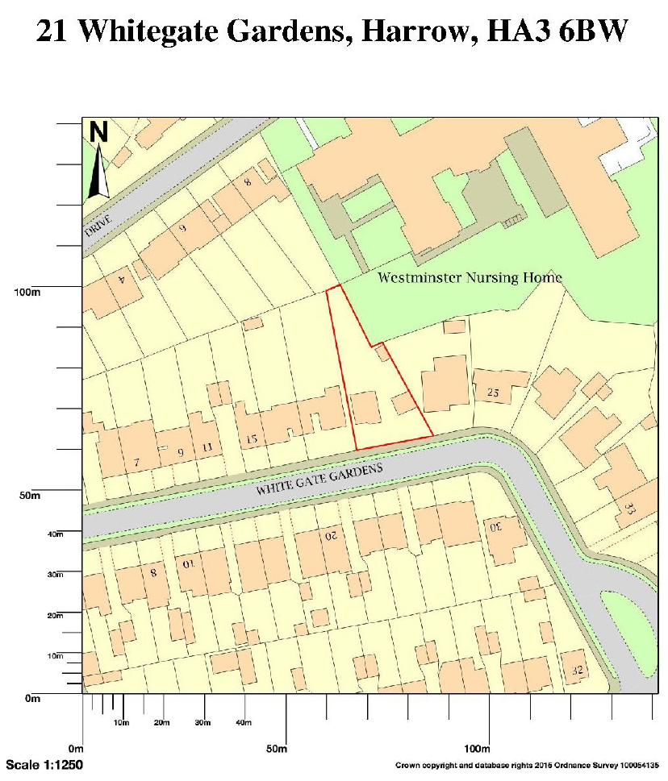
APPENDIX 3: SITE PHOTOGRAPHS

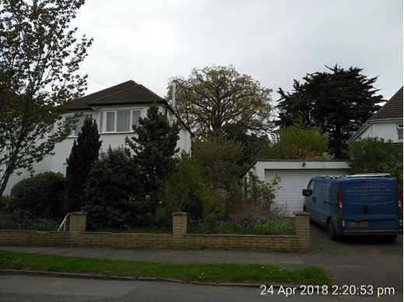
Front Elevation

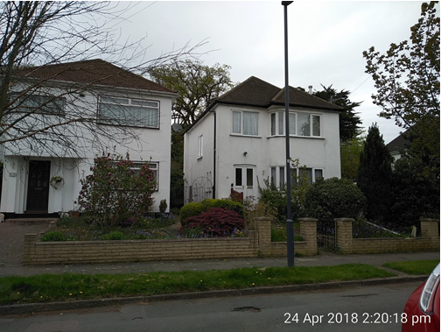
Front Elevation

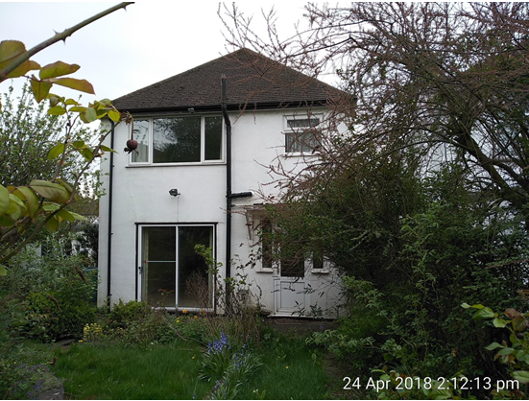
Rear elevation

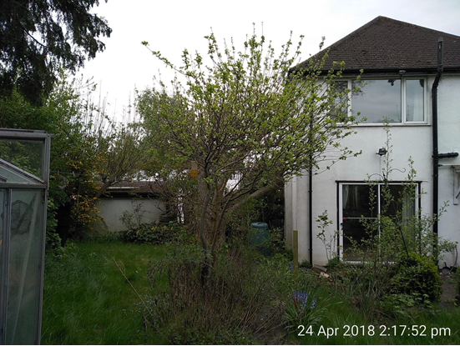
Rear elevation

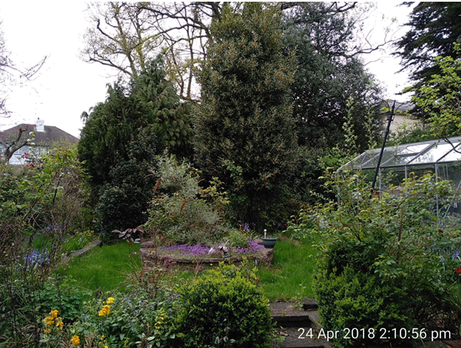
Rear garden

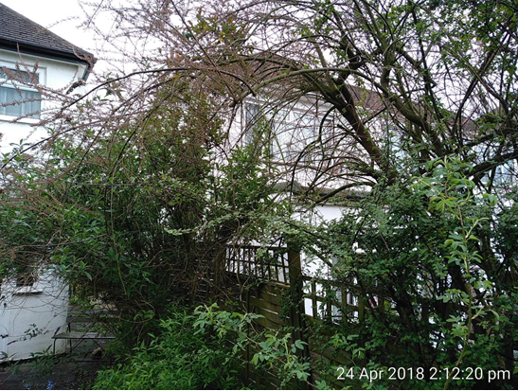
Towards rear of no. 19
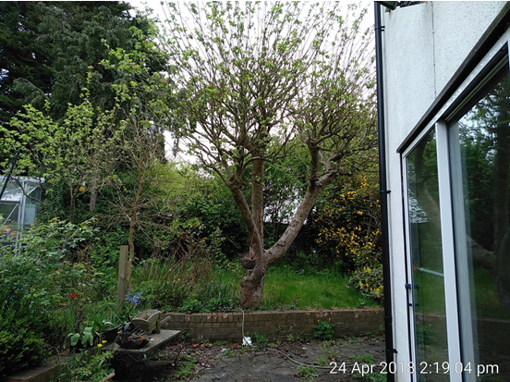
Towards side of no. 23 (from rear of no. subject dwelling)

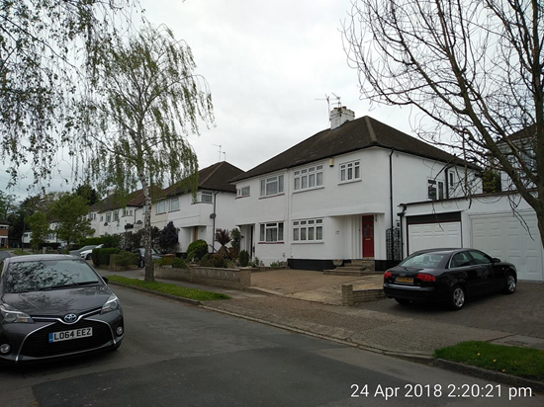Street context- towards no. 19
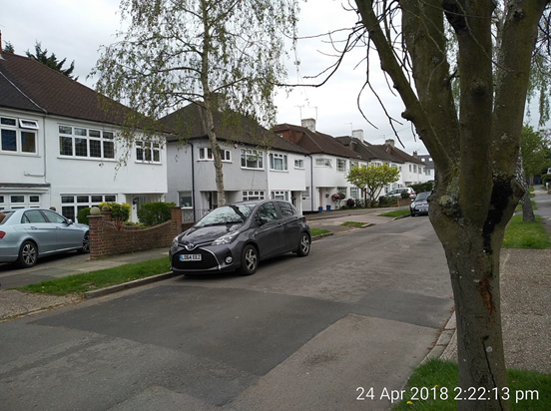
Street context- opposite side towards south-west

APPENDIX 4: PLANS AND ELEVATIONS

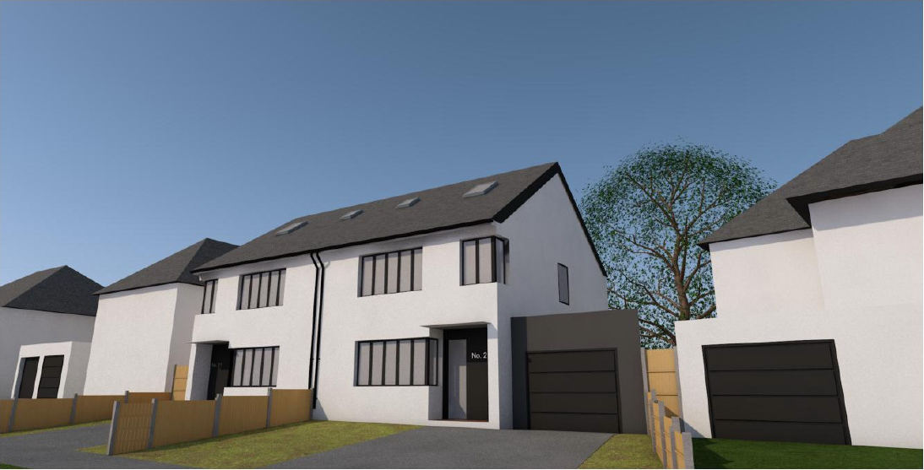
Visualised 3D Model

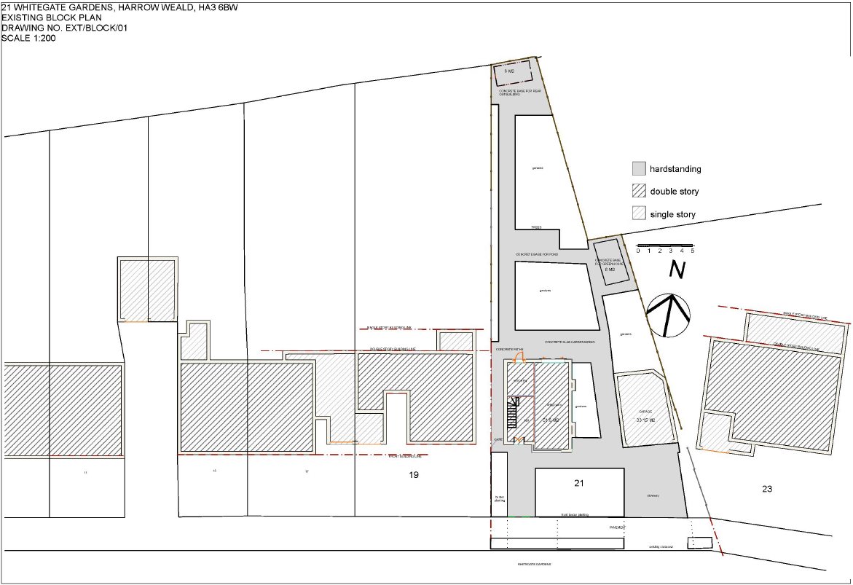
Existing site plan

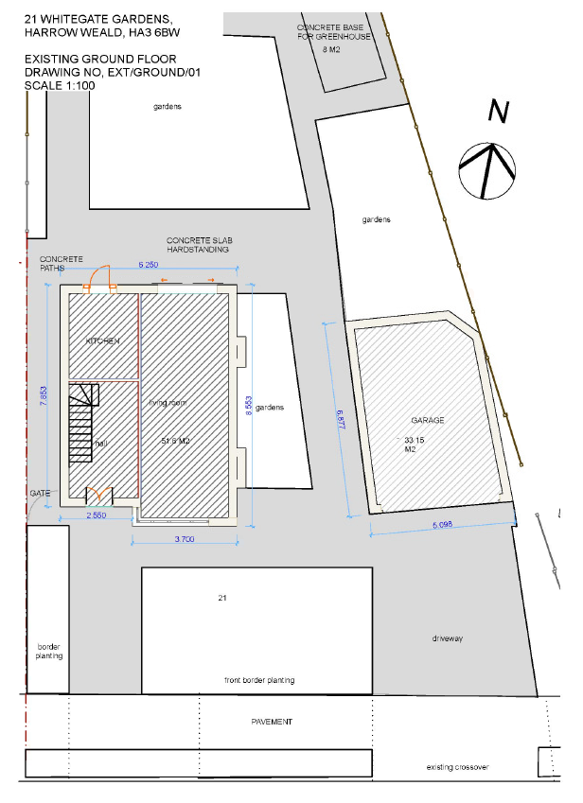
Existing ground floor plan

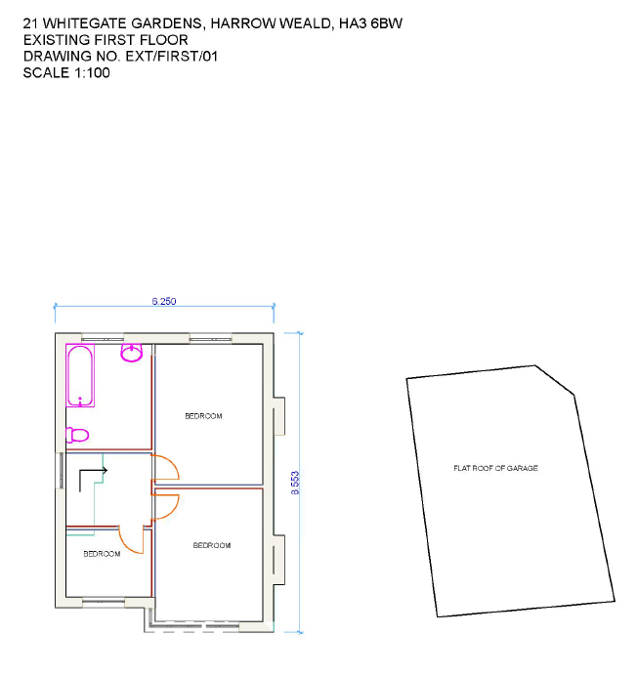

Existing first floor plan
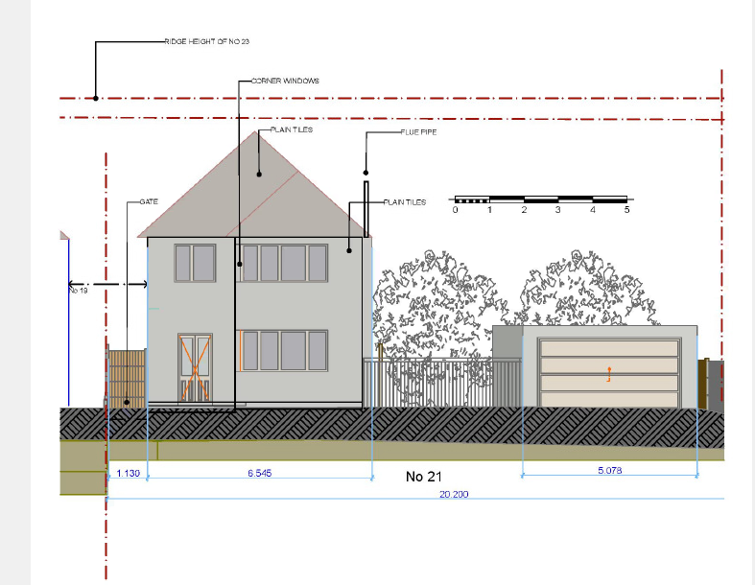

Existing front elevation

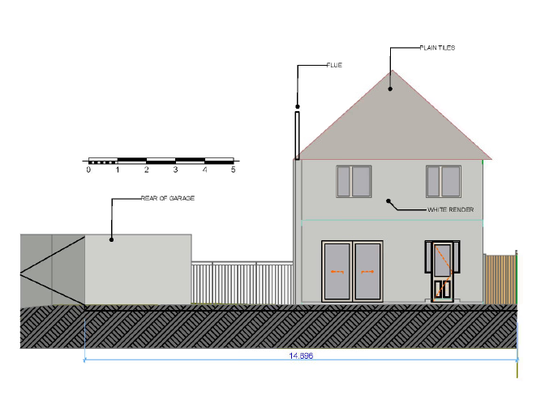
Existing rear elevation

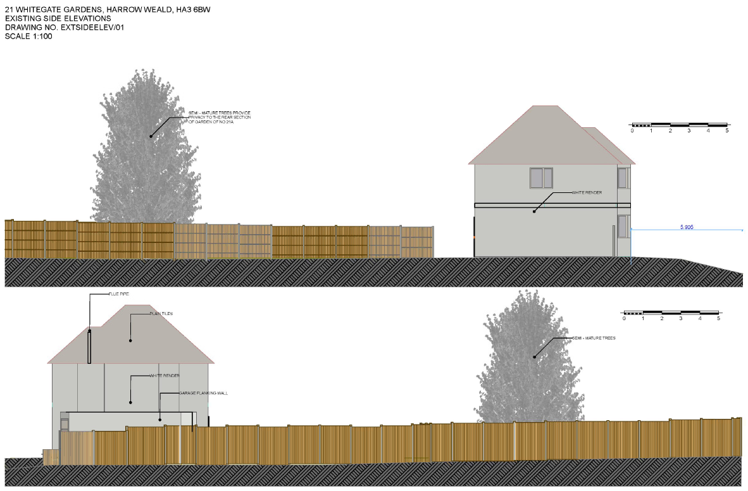

Existing side elevations

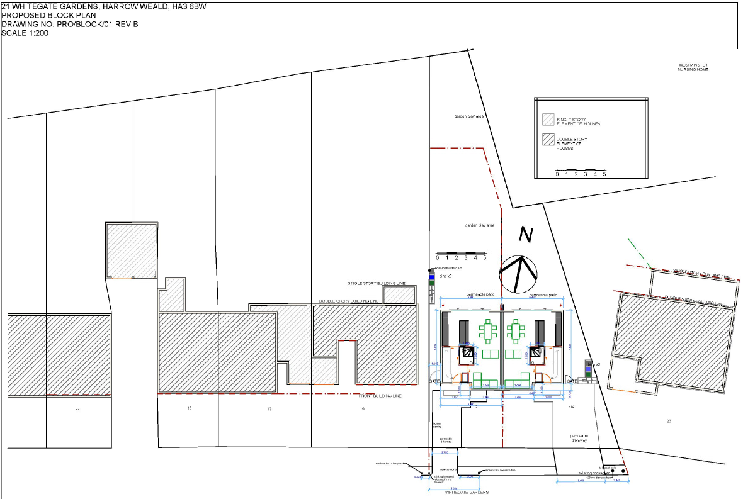
Proposed site plan

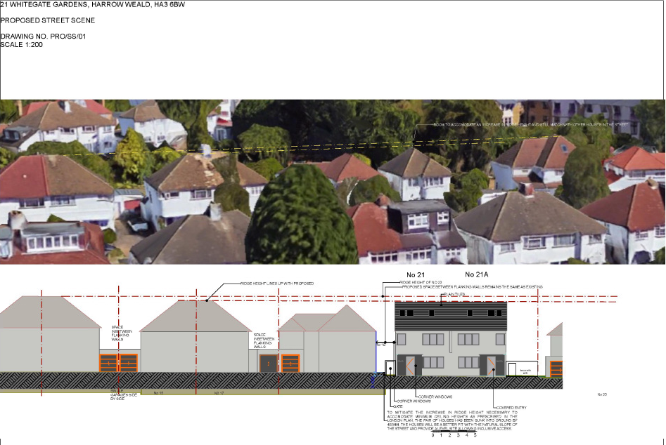

Proposed street context
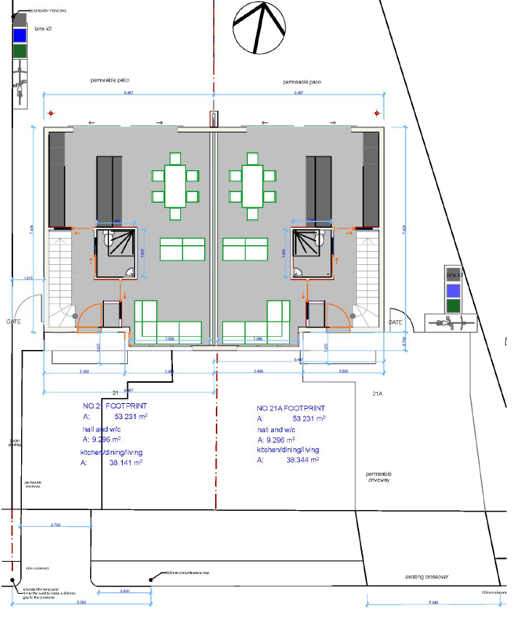

Proposed ground floor plan

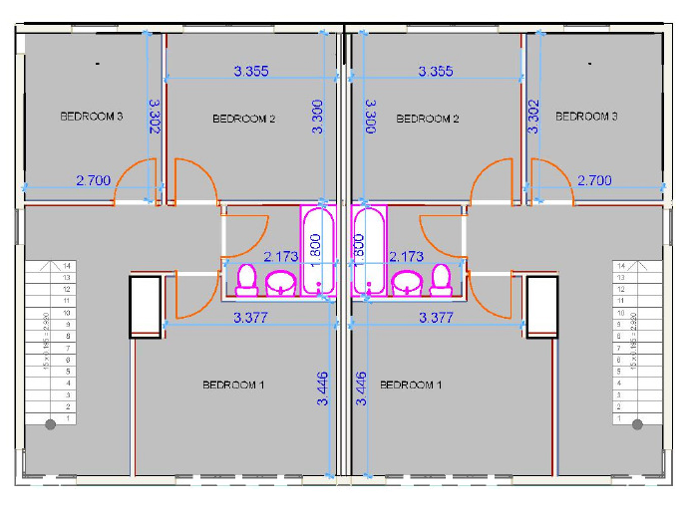

Proposed first floor plan
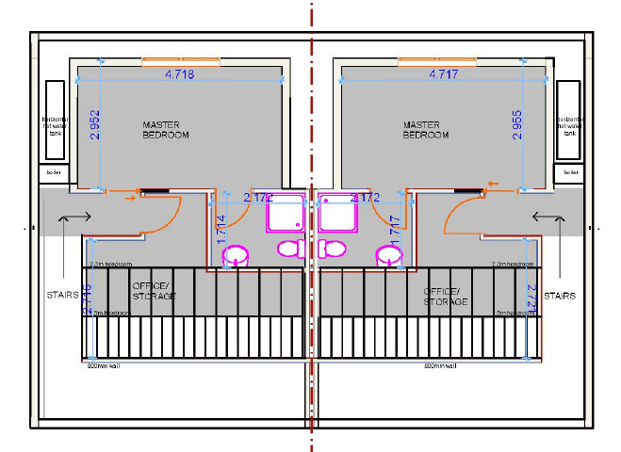
Proposed second floor plan
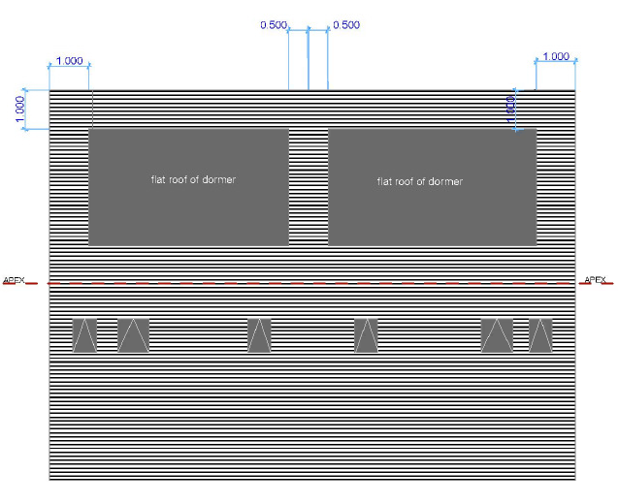
Proposed roof plan

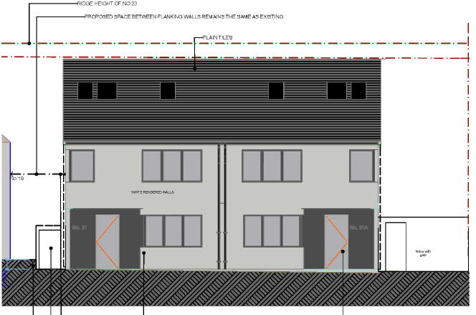

Proposed front elevation

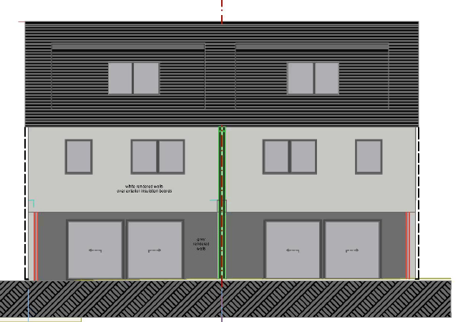

Proposed rear elevation

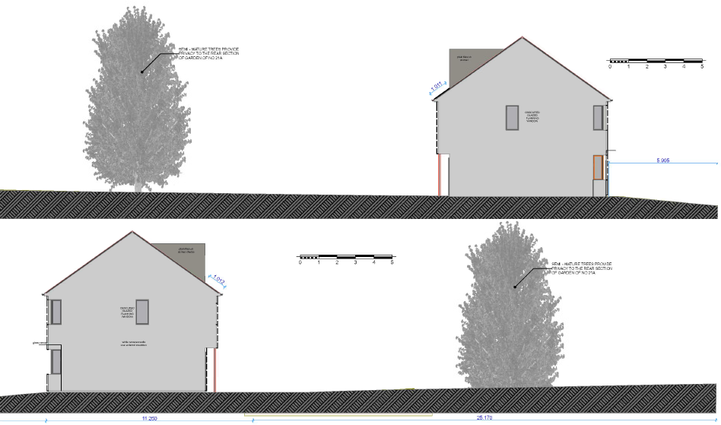

Proposed side elevations

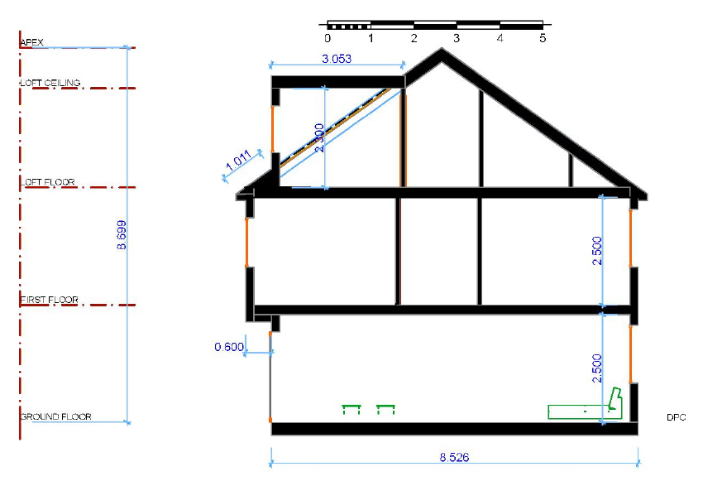

Proposed section

This page has been left intentionally blank

